**Definition: Create and adopt design for Dark Mode with Selection Colors.**

**Solution:**

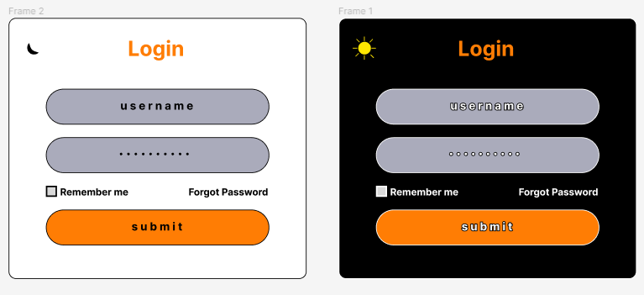

**Steps:**

* First Open Figma in browser mode.
* Then create the new document **File à New Figma Design.**
* Now add one frame using the Frame tool and select a **Desktop** frame of width=”**1100px”** and height=”**550px”** on your canvas.
* **For the Light Login Page:**
* Take one frame of width=**”400px”** and height=**”350px”**. Fill the frame with the colour **“**#**FFFFFF”.**
* Take the text tool and write “**Login**” of font=”**28**” and colour “#**FF7D04**”.
* Take One Rectangle width=”**300px**” & height=”**50px**” and colour is “#**AAABBB**”. in the rectangle take a text tool & write “**Username**” with the colour “#**000000**”.
* Below that rectangle take another Rectangle width=”**300px**” & height=”**50px**” and the colour is “#**AAABBB**”. in the rectangle take a text tool & write “**Password” with** the colour “#**000000**”.
* Now take the text tool and write “**Remember me**” of font=”**13**” and colour “#**FFFFFF**”.
* Beside that text box take another one and write “**Forgot Password**” with the font=”**13**” and colour “#**FFFFFF**”.
* Take One Rectangle width=”**300px**” & height=”**50px**” and colour is “#**FF7D04**”. in the rectangle take a text tool & write “**Submit” with** the colour “#**000000**”.
* Lastly, add an ellipse of width & height=”**15px**” and shape it as the moon to represent the dark mode button.
* **Now for the Dark Login Page:**
* Take one frame of width=**”400px”** and height=**”350px”**. Fill the frame with the colour **“**#**000000”.**
* Take the text tool and write “**Login**” of font=”**28**” and colour “#**FF7D04**”.
* Take One Rectangle width=”**300px**” & height=”**50px**” and colour is “#**AAABBB**”. in the rectangle take a text tool & write “**Username**” with the colour “#**FFFFFF**”.
* Below that rectangle take another Rectangle width=”**300px**” & height=”**50px**” and the colour is “#**AAABBB**”. in the rectangle take a text tool & write “**Password” of** colour “#**FFFFFF**”.
* Now take the text tool and write “**Remember me" with** the font=”**13**” and colour “#**FFFFFF**”.
* Beside that text box take another one and write “**Forgot Password**” with the font=”**13**” and colour “#**FFFFFF**”.
* Take One Rectangle width=”**300px**” & height=”**50px**” and colour is “#**FF7D04**”. in the rectangle take a text tool & write “**Submit**” with the colour “#**FFFFFF**”.
* Lastly, with the help of an ellipse and a line tool, draw a sun of width & height=”**30px**” to represent the light mode button.
* Now, Go to the **Export** button in the property panel. And **Export** it with .**JPG/.PNG** format.